Name: ________________________________________________________ Week of: __________________________

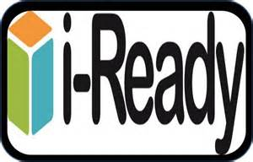
i-Ready Math Log is due on MONDAYS!!!
Your child will be responsible for completing i-Ready Math for Home Learning.
You should monitor that your child is completing 2 lessons in Math.
Below you will find a log for your child to record the 2 lessons completed weekly.
Your child should write the date of when they completed the skill, name of the Skill Lesson completed and the percentage score at the end of the session. Please initial that your child has completed their weekly lessons on the space provided.
i-Ready Weekly Sessions Log
 | Date | Did you do a complete lesson? Yes or no | i-Ready Math Skill | % | Parent Signature
Session #1

Session #2

To be completed by the teacher:

i-Ready Math Average %

